Project Name | RK-HEALTH
Date | 3 July 2026
Team ID

Phase 2: Solution Architecture

Technical System Architecture
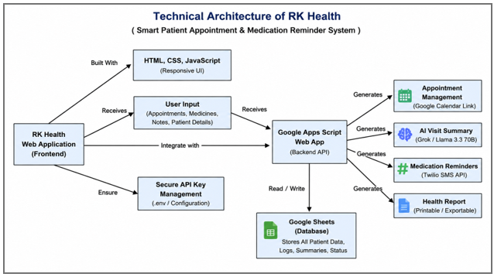
Figure 1: Interface & Dashboard Screenshot of the RK-HEALTH Platform
RK-HEALTH Solution Architecture Layers
Layer | Components | Tech Stack | Role & Interaction
Presentation Layer (Frontend) | Single Page Application (SPA), Glassmorphism UI, 3D Login background, Dark Mode | HTML5, CSS3, ES6+ JS, Three.js, Font Awesome 6 | Handles direct user interactions, local rendering, theme switching, and client-side notifications.
Application Logic Layer | Local DB Wrapper, State Manager, AI Symptom Triage, Calendar Link Generator | Vanilla JS, Web localStorage API | Manages client-side CRUD logs, local user authentication, and formats request payloads.
Backend API Gateway | Flask REST Server, Twilio Wrapper, GAS Sheets Proxy | Python 3.13, Flask, Gunicorn | Handles routing for SMS reminders, enables CORS, and acts as secure proxy for Google Sheets sync.
Data & Integration Layer | Browser storage, cloud sync database, serverless AI API | localStorage API, Google Sheets (via Apps Script), Groq API (LLaMA 3.3-70B) | Persists user data offline-first, syncs logs to Sheets for cloud backup, and processes chat queries.

